**PROJECT NAME: FLYAWAY TO BOOKING PORTAL**

**DEVELOPER NAME: Kapil Davey**

**GitHub Link:** [**https://github.com/kapildavey/Phase-2.git**](https://github.com/kapildavey/Phase-2.git)

**Output:**

**An admin login page:**

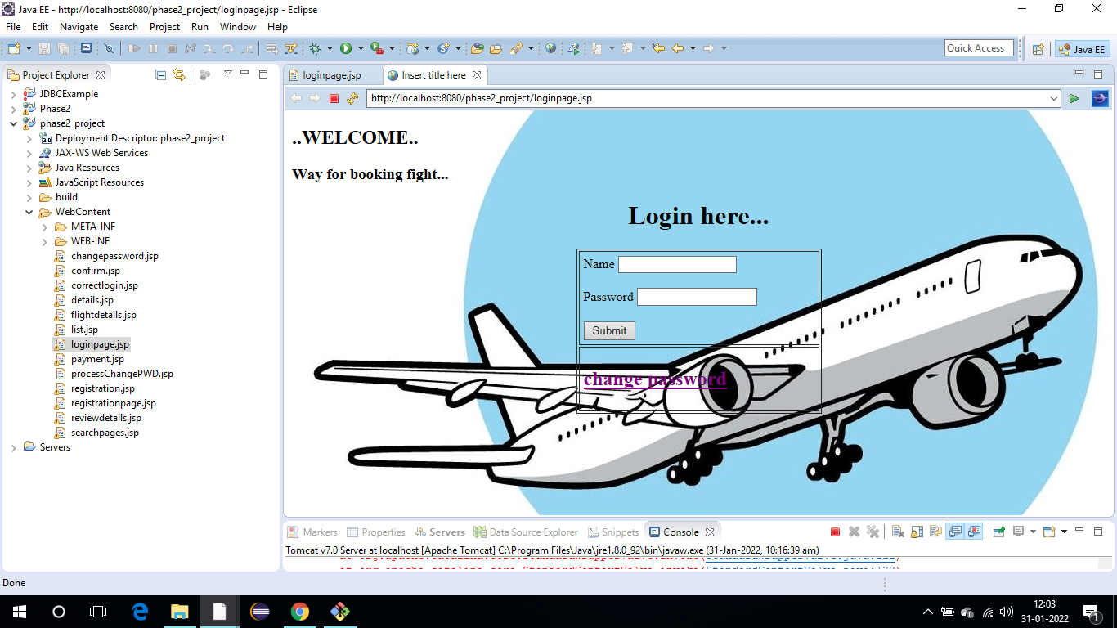

**An admin login page where the admin can change the password after login, if he wishes:**

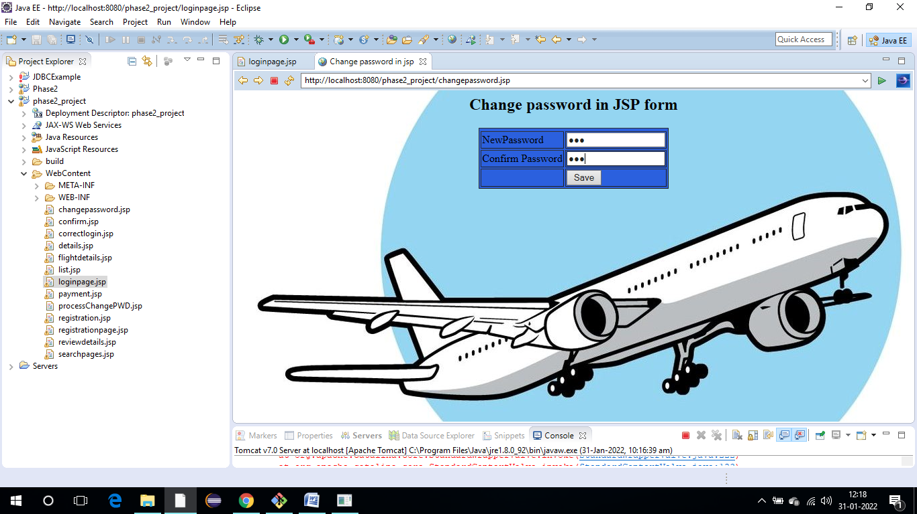

**A master list of places for source and destination:**

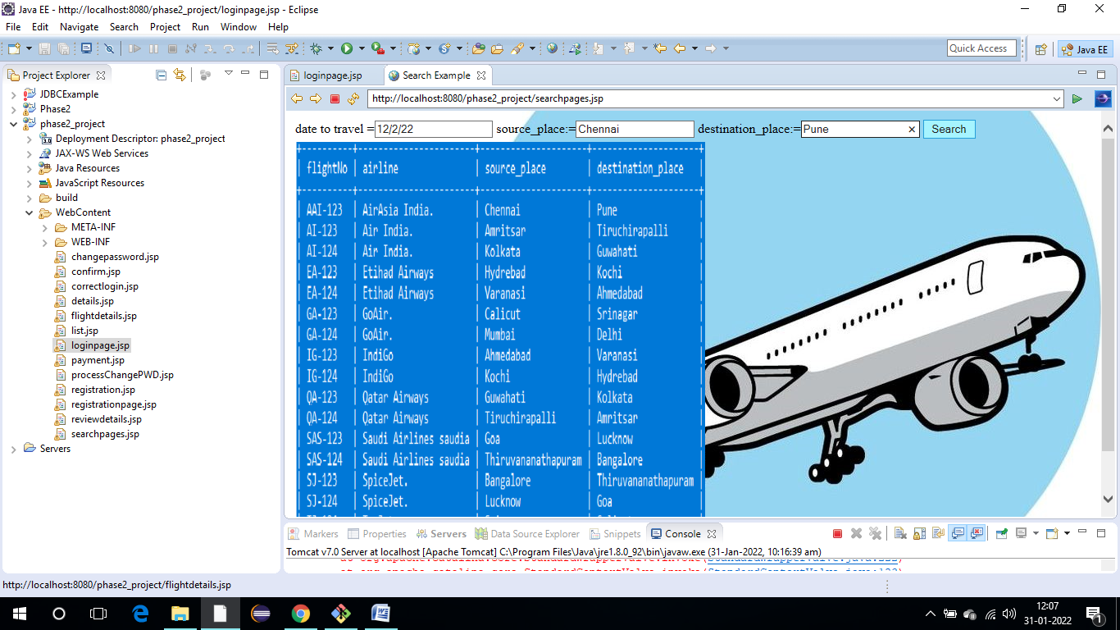

**A master list of airlines, A list of flights where each flight has a source, destination, airline, and ticket price:**

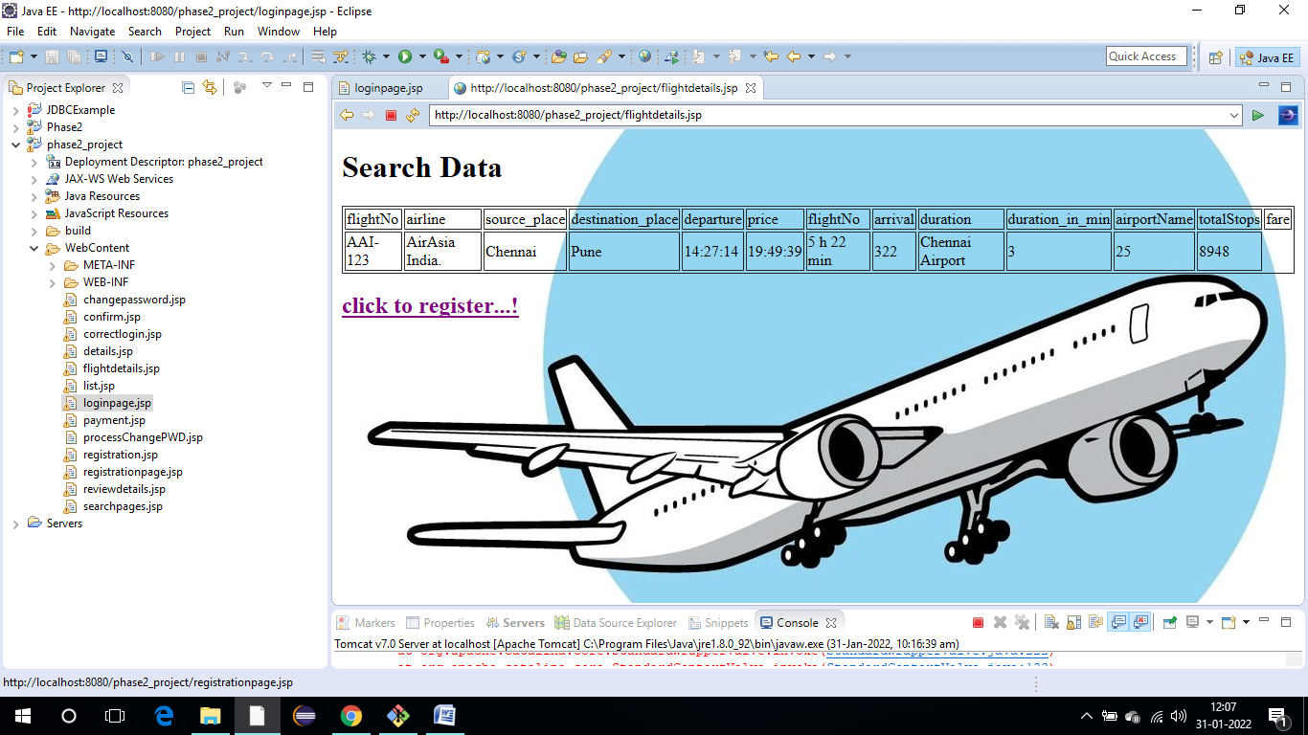

**Register page where they must fill in their personal details:**

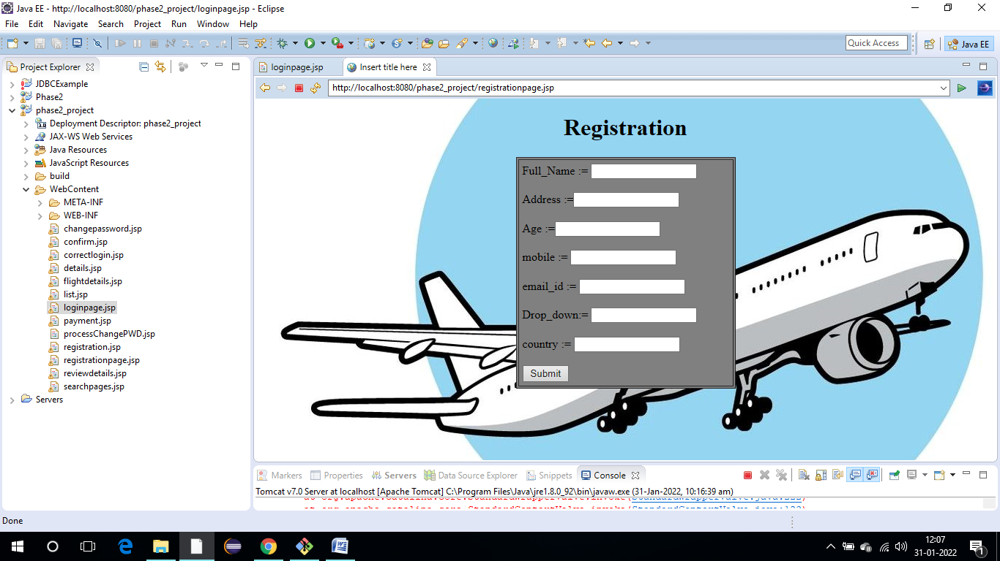

**The flight details of the flight that they are booking, and the payment is done via a dummy payment gateway:**

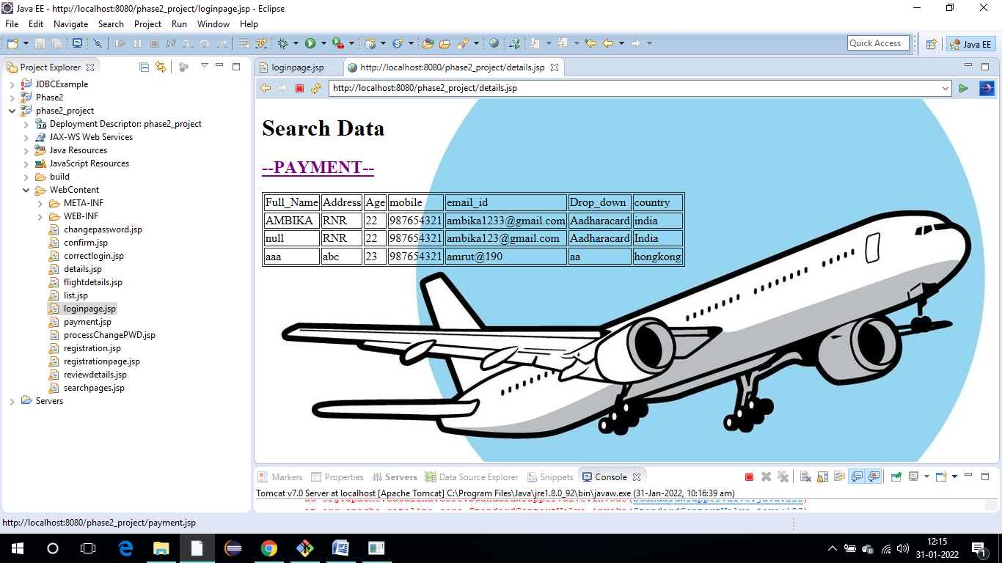

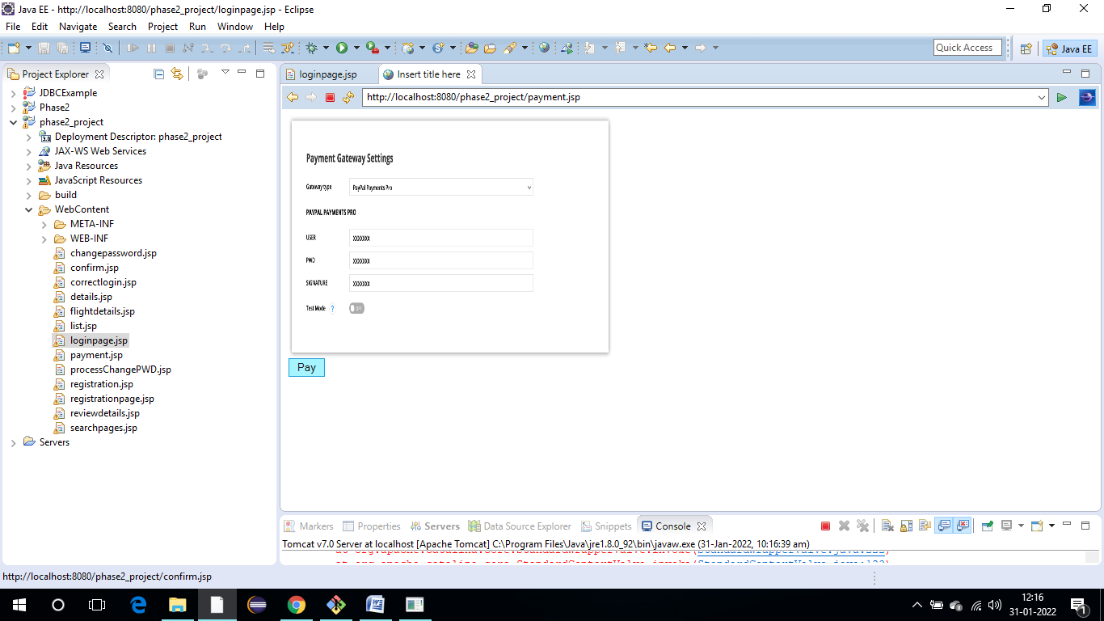

**On completion of the payment, they are shown a confirmation page:**

